Biology
Naming Tissues

Student's Name
Institution Affiliation
Course Number and Name
Instructor's Name
Assignment due Date

Biology
Naming Tissues
- Betz cells
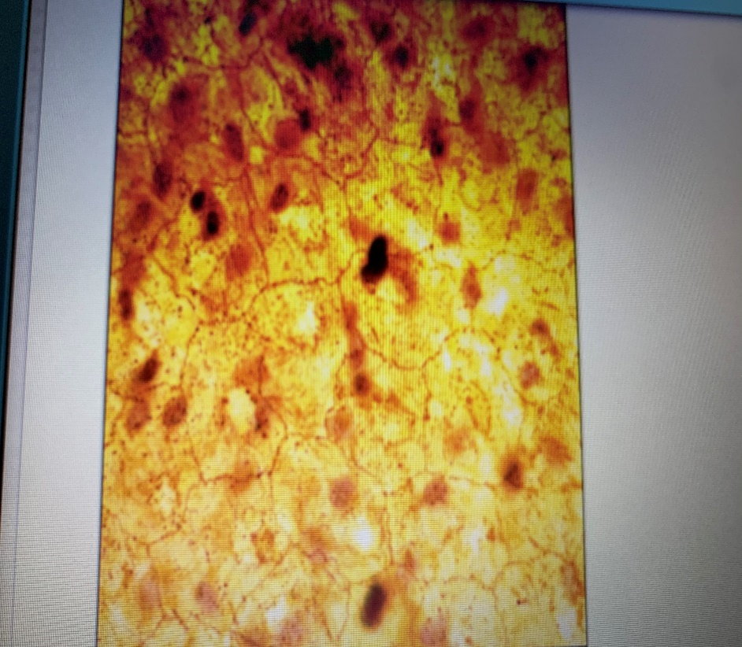
Betz cells are pyramid-like nerve cell situated inside the 5th film of the primary motor cortex
Characteristics of Betz Cells
- They have a Multipolar Pyramidal shape
- They are one of the longest axons in the body
- They are higher motor nerve cells
- They direct their neurites down to the backbone through the corticospinal area
Betz cells are located in the motor areas of the cerebral cortex
The Betz cells' function is to direct their neurites down to the backbone through the corticospinal area (Phillips, 1956). In persons, they synapse unswervingly with forwarding horn cells which in chance synapse unswervingly with their board physiques.

- Platelet blood cells
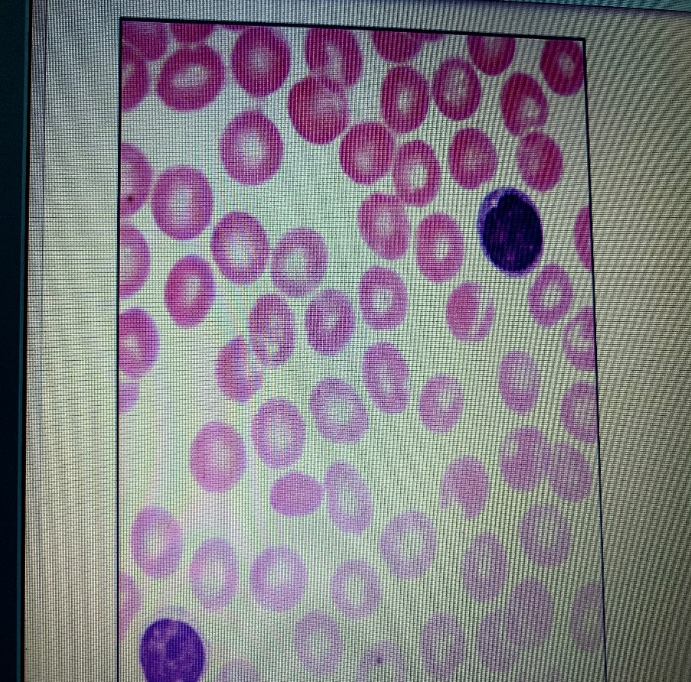
Platelets are tiny cells shaped like plates produced by very large bone marrow cells called megakaryocytes.
Characteristics of Platelets blood cells
- They are the smallest blood cells
- They are produced by very large bone marrows called megakaryocytes
- They have a smooth disk shape
- They have a membrane bearing numerous glycoprotein receptors
Platelets are located in the blood, and their function is to prevent bleeding (Harrison, 2005).

- Elastic cartilage
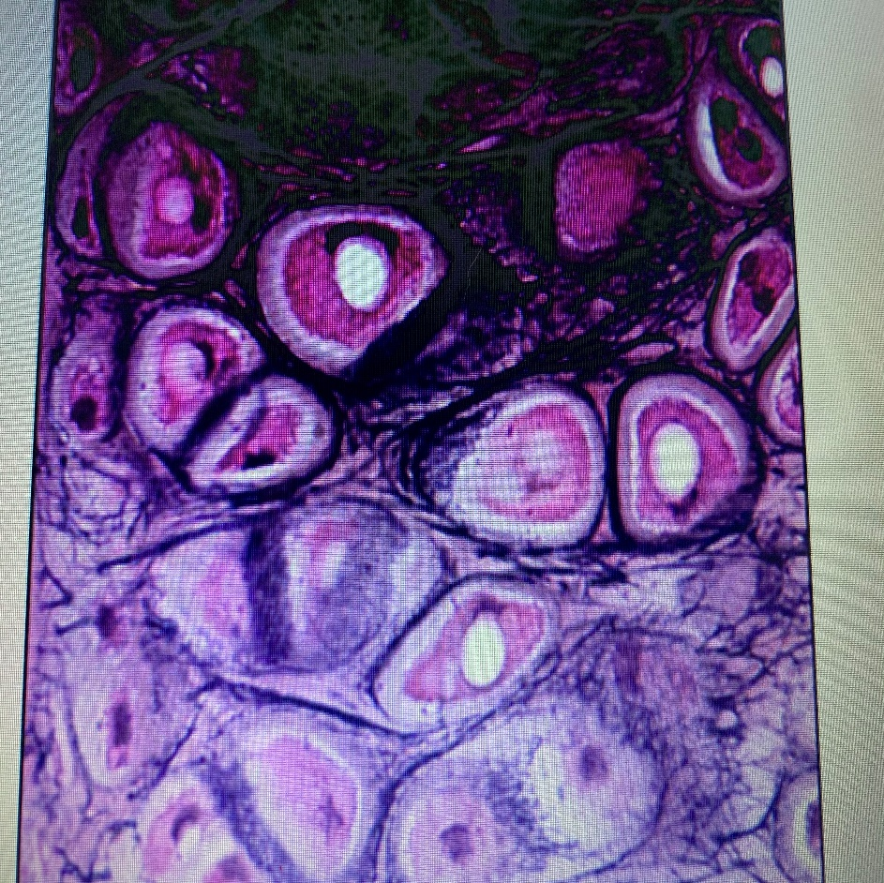
Elastic cartilage or yellow fibrocartilage is a type of cartilage that provides both strength and elasticity to some body parts, such as ears (Rodriguez et all., 1999).
Characteristics of Elastic cartilage
- They are yellow in appearance
- It contains elastic fibres that make it more pliable than other forms
- It makes up the external ear, the auditory tube of the middle ear and the epiglottis in human.
- They contain chondrocytes that lie between the elastic fibres
Elastic cartilage is located in some body parts like the ears, and its purpose is to offer strength and elasticity to these body parts.

- Hyaline cartilage
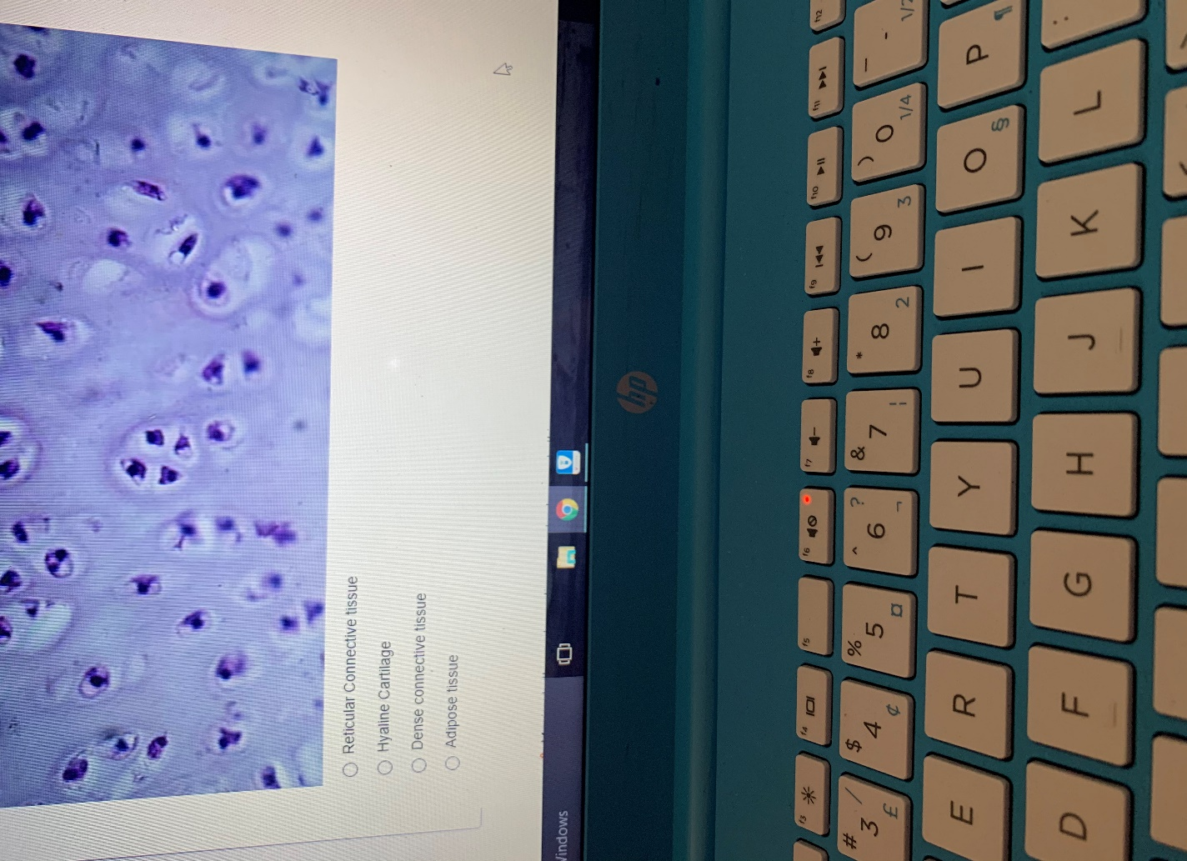
Hyaline cartilage is a luminous bluish-white type of gristle contemporary in the joints, the respirational tract, and the undeveloped skeleton
Characteristics of Hyaline cartilage
- It is glass-like but translucent bluish-white cartilage
- It is found in many joint surfaces
- It has a considerable amount of collagen
- It is pearl-grey in colour.
Hyaline cartilage is located on many joint outsides, in the ribs, nose, larynx, and trachea. The main purpose of Hyaline cartilage is to grasp the body together. It offers sustenance and flexibility to diverse body parts (Lehner et all.,1989).

- Trichinella spiralis
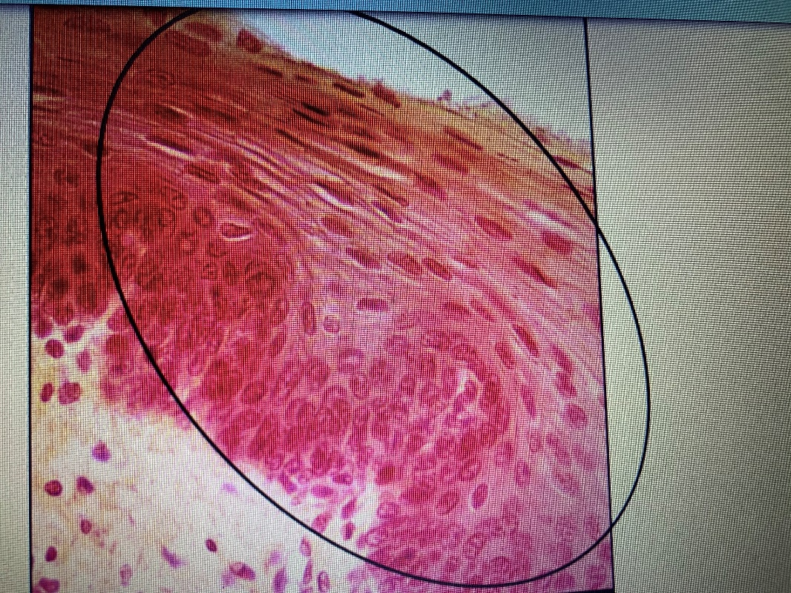
Trichinella spiralis is a live-bearing nematode worm occurring in gnawers, livestock, bears and humans, and it's accountable for the trichinosis disease (Despommier, 1993).
Characteristics of Trichinella spiralis
- It is the smallest known roundworm of humans.
- Males of these parasites are half smaller than the females
- The figure of the worm is slenderer at the front than at the subsequent end
- It infects almost all types of mammals
Trichinella spiralis worms are located around the columnar epithelial cells of small intestines, and it is the main cause of trichinosis infectious disease

- Cardiac muscle
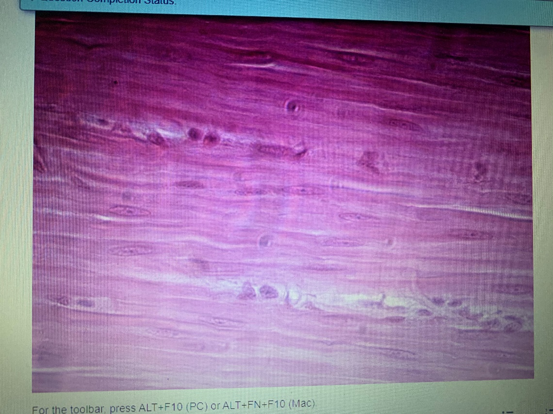
The cardiac muscle is one of the three vertebrates, and it is a spontaneous, striated muscle that creates the main tissue of the walls of the heart.
Characteristics of Cardiac muscle
- Most contain one nucleus, but some have two.
- Form an extremely divided cellular system in the heart
- They are allied end to end by interpolated disks
- They are prearranged into layers of myocardial tissue that are enfolded around the chambers of the heart.
Cardiac muscle cells are located in the heart walls, and their main function is to keep the heart pumping through involuntary movements (Sommer & Johnson, 1969).

References
Despommier, D. D. (1993). Trichinella spiralis and the concept of niche. The Journal of parasitology, 472-482.
Harrison, P. (2005). Platelet function analysis. Blood reviews, 19(2), 111-123.
Lehner, K. B., Rechl, H. P., Gmeinwieser, J. K., Heuck, A. F., Lukas, H. P., & Kohl, H. P. (1989). Structure, function, and degeneration of bovine hyaline cartilage: assessment with MR imaging in vitro. Radiology, 170(2), 495-499.
Phillips, C. G. (1956). Intracellular records from Betz cells in the cat. Quarterly Journal of Experimental Physiology and Cognate Medical Sciences: Translation and Integration, 41(1), 58-69.
Rodriguez, A., Cao, Y. L., Ibarra, C., Pap, S., Vacanti, M., Eavey, R. D., & Vacanti, C. A. (1999). Characteristics of cartilage engineered from human pediatric auricular cartilage. Plastic and reconstructive surgery, 103(4), 1111-1119.
Sommer, J. R., & Johnson, E. A. (1969). Cardiac muscle. Zeitschrift für Zellforschung und mikroskopische Anatomie, 98(3), 437-468.

